**Q1: WAP to print the Following:**



**Q2: WAP to print the Following:**



**Q3: WAP to print the following asterisk pattern:**

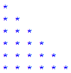

**Q4: WAP to create a function traiangle to print the following asterisk triangle pattern:**



**Q5: Write a python program to print following multiplication table on the screen**

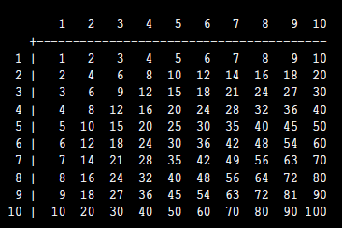8 | 8 16 24 32 40 48 56 64 72 80

9 | 9 18 27 36 45 54 63 72 81 90

Q6. Write a program in Python to produce Star triangle.

*

***

*****

*******

*********

***********

*************

***************

*****************

10 | 10 20 30 40 50 60 70 80 90 100